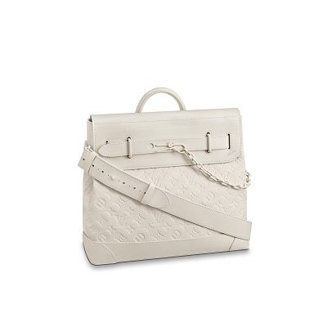

Steamer PM H25 – Bags

PRODUCT DETAILS

**- L 13.8 x H 12.6 x W 6 inches**

**- Powder White**

**- Taurillon leather**

**- Cowhide leather trim**

**- Textile lining**

**- White metal hardware**

**- Embossed Monogram pat tern**

**- Mat t white resin chain**